2016 HOGMANAY CEILIDH
with the
CROMARTY CEILIDH BAND
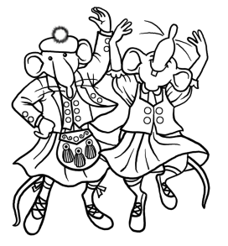
BRING YOUR OWN DRAMS, OATS, REELS!
Victoria Hall, Cromarty
31st December 21.00 – 00.30 hrs

Tickets
Adults £10 Children £5
at the Community Market on Saturday 10 December
and then available from The Emporium

Profits to
Cromarty Community Care, Cromarty Courthouse & Cromarty Rising

